**OPERATING SYSTEM**

why operating system?

OS does the resource management like the distribution between the memory, gpu, cpu, and disk.

OS act as interface.

OS also writes the memory and resource management code(arbitration), by this OS reduces the bulkiness of the app.(abstraction)

Memory protection and isolation is another thing of the OS.

Access to the computer hardware.

What is OS?

The OS is a piece of software that provide the above things to the user.

Goals of OS:

1. Maximum CPU utilization.
2. To avoid process starvation.
3. High priority job execution.

Types of OS:

1. **Single process OS:** only one job at a time, very old type of OS, no maximum CPU utilization, there will be process starvation. High priority job many at times cannot be executed. Ex: MS Docs.
2. **Batch processing OS:** there are N user and each of them had submitted their jobs, now there is an operator that sorts the jobs and bring them in batches and each batch executes sequentially now in this also there is no max. CPU utilization, there is process starvation and also there is no high priority job execution. Ex atlas.
3. **Multi- programming OS:** when there are multiple jobs and one job goes in the i/o state the other jab is taken by the cpu and state of the first job is being saved in the process control block (PCB). This complete process is called context switching. Ex THE
4. **Multi-tasking OS:** there is single cpu and there is context switching but the only diff between the multi programming and the multi tasking is that there is time sharing. Ex: CTSS.
5. **Multi-processing OS:** there is context switching, there is time sharing the only diff is that there is more than one CPU. Ex : windows.
6. **Distributed OS:** also called loosely coupled, there are one OS and multiple CPU and memory connected over the world and whenever they want they can execute the task to any oof the cpu.
7. **RTOS:** real-time OS, we use this where we want very high accuracy and very negligible chances of error, ex: air traffic control, industrial application etc.

**What is program?**

Program is an executable file that contains certain set of instructions written to complete the specific job. It is compiled code, ready to execute. Stored in disk.

**What is process?**

Program under execution.

**What is thread?**

The light weight process is called thread, the minute process that can be independently executed.

**What is multi-threading?**

A single task is broken down into multiple threads (smaller tasks) and they executes asynchronously or simultaneously so the task gets completes in lesser time. For multi-threading we need multiple CPU’s more than one. So that each sub task is executed by different CPU. Used to achieve parallelism. Ex: multiple tabs in a browser, text editor

**Difference between multi-tasking and multi-threading?**

**Multi-tasking:** more than 1 process concept, there is isolation and memory protection, processes are scheduled.

**Multi-threading:** more than one thread, there is no memory protection or isolation, threads are scheduled., more the number of cores then more we can divide into threads.

**Difference between the thread context switching and the process context switching?**

OS saves current state of thread and switches to another thread of same process, does not include the switching of memory space address, fast switching, CPU cache state is reserved.

OS saves current state of process and switches to another process, includes switching of memory space address, slow switching, CPU cache state is flushed.

**Components of OS:**

1. **User space:** the space where convenient apps are run is called user space, no hardware access, provides convenient space to user. Ex. GUI(graphical user interface), CLI(command line interface).
2. **Kernel:** kernel has the access to underlying hardware. This is also the heart of the OS,

User space --🡪 kernel ----🡪 hardware

**Functions of kernel:**

1. **Process management** (creation, termination)

scheduling of process or thread.

Process communication.

Process synchronization.

1. **Memory management** (allocate, deallocate, free space management)
2. **File management** (create, manage, delete), directory management.
3. **I/O management** (pen drive, other external devices). (spooling, buffering, caching).

**Types of kernels:**

1. **Monolithic kernel:** process mgmt., memory mgmt., I/O mgmt., file mgmt. all is present within the same kernel, oldest type of kernel.

Adv: the communication is fast as they are present in the same kernel.

Dis adv.: kernel become bulky and less reliable, ex. Linux

1. **Micro kernel:** the process management and memory management is within the kernel and file and I/O management is with the user space.

Adv: less bulky and more reliable, more stable.

Dis adv.: the communication is little slow. There is overhead. Ex. L4 linux etc.

**How is the communication between user mode and kernel mode?**

It is through inter-process communication:

Using shared memory.

Message passing

1. **Hybrid kernel:** combined approach, file management is under user space and other three inside kernel space. Ex: MacOS, windows.
2. **Nano kernel**: not very imp.
3. **Exo kernel:** not very imp.

**System calls in the OS:**

The only way to switch from user mode to kernel mode is through system calls. There is an interface between user space and the kernel space named SCI (system call interface).

**Types of system calls:**

1. **Process control.**
2. **File management.**
3. **Device management.**
4. **Information maintenance.**
5. **Communication management.**

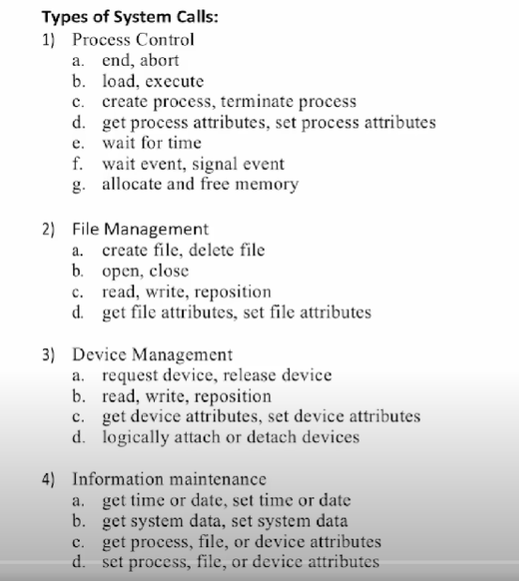

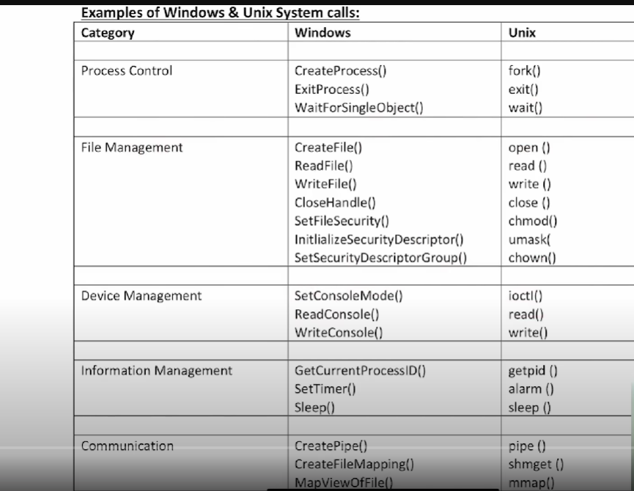

**How OS boots up?**

**Five steps of the booting up:**

1. **Turning ON the power supply**, as soon as the power supply turned ON the motherboard and other components gets the power supply.
2. **CPU loads BIOS or UEFI** (advance version of BIOS).
3. BIOS or UEFI runs some tests and init the hardware, loads some setting from a memory area backed by **CMOS battery**. Programs load with the settings then it runs **POST (power on self-test)** to check the essential hardware components.
4. BIOS or the UEFI hands off to boot devices (disk, pen drive, HDD/SSD), then boot loader runs the actual program that loads the OS, this is present in the MBR (master boot record), present in old devices, or the EFI (partition in the disk).
5. Boot loader loads the full OS.

**32 bits vs 64 bits?**

1. Addressable space (32bits – 2^32-1, 64bits – 2^64-1)
2. Resource usages better in 64bits.
3. Calculation much fast in 64bits.
4. 64bits CPU can run both 32 and 64bit OS, while 32bit can run 32bit OS.
5. Better graphic performance.

**Comparison between different storages used in computers?**

1. **Resister** (smallest memory and closest to CPU).
2. **Cache** (memory that stores temporary data that are more frequently used)
3. **Main memory** (contains the program under execution)

The above the three are called **primary memory.**

1. Electronic disk
2. Magnetic disk
3. Optical disk
4. Magnetic tapes

These 4 are called secondary memory.

**Comparison:**

**Cost:** resisters are highly costly, made of rare earth metals.

Next comes the cache and then main memory.

**Access speed:** resister then cache then main memory and then secondary one.

**Storage size:** resister then cache then main memory.

**Volatility:** main memory data is flushed off as the computer is turned off but the secondary memory remains saved.

**How operating system created a process?**

**There are total of 5 steps:**

1. Load the program and the static data to memory, used for initialization.
2. Allocate runtime stack.
3. Allocate heap, part of memory used for dynamic allocation.
4. I/O task input handle, output handle and error handle.
5. OS hands off the control to main.

Architecture of process:

Stack ------------- heap----data-----text.

Stack overflow-> assign base case.

Memory overflow->deallocate unnecessary objects.

**Attributes of process:**

To study this, we need to focus upon PCB (process control block).

1. Process ID: unique ID to the process.
2. Program counter: keeps the track on which process currently we are.
3. Process state: to check the state of the program, new, wait, RUN…..
4. Priority: priority of the job.
5. Register: save the registers when there is context switching.
6. Open file/ list:
7. Open devices list.

**What are different process states in OS?**

**New state:** program to process begin done.

**Ready state:** process is in memory or in ready queue

**Running state:** CPU is being allocated and the process is running

**Waiting state:** while running sometimes there is I/O call/ instruction so the process goes in waiting state and waits for the I/O to complete.

**Termination state:** the process is complete and there is no more the existence of the process.

Job scheduler (long term scheduler) handles degree of multi programming and CPU scheduler (short term scheduler) handles ready to running state.

**Medium term scheduler:**

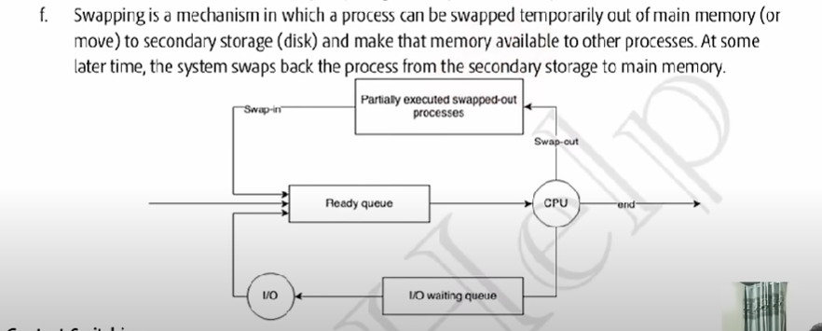

**Context switching in OS:** Context switching in an operating system refers to the process of storing the state of a currently running process or thread so that it can be resumed later and restoring the state of another process or thread to start or resume its execution. This allows multiple processes to share a single CPU and gives the illusion that they are running simultaneously (multitasking).

**Orphan process:** the process that does not has parent or we can say that parent process has been terminated, and it is still running, first process of OS is init.

**Zombie process:** the process that has been terminated or its execution is complete but it still has an entry in the process table. It usually occurs for the child process, once the zombie process is eliminated the process is removed from the table, this one is called reaping.

**The two types of CPU scheduling?**

1. **Non-Premptive scheduling:** the process will not leave the CPU until it is terminated or it is sent to the wait state. Process starvation is more in this.
2. **Pre-emptive:** the process will leave the CPU when it is terminated, sent to wait state or time quantum for that process expires. More CPU utilization. More overhead.

**Goals of the CPU scheduling:**

1. **More CPU utilization.**
2. **Minimum turn-around time**. **(TAT = CT-AT)**
3. **Min. wait time. (WT = TAT-BT)**
4. **Min. response time.**
5. **Max. throughput (max. process executed per unit time).**

**Types of Scheduling algorithms:**

1. **First come first serve (FCFS):** the first process that will come in the ready queue, it will be assigned CPU and so on.

One of the drawbacks of this is convoy effect which is calculated using gantt chart. 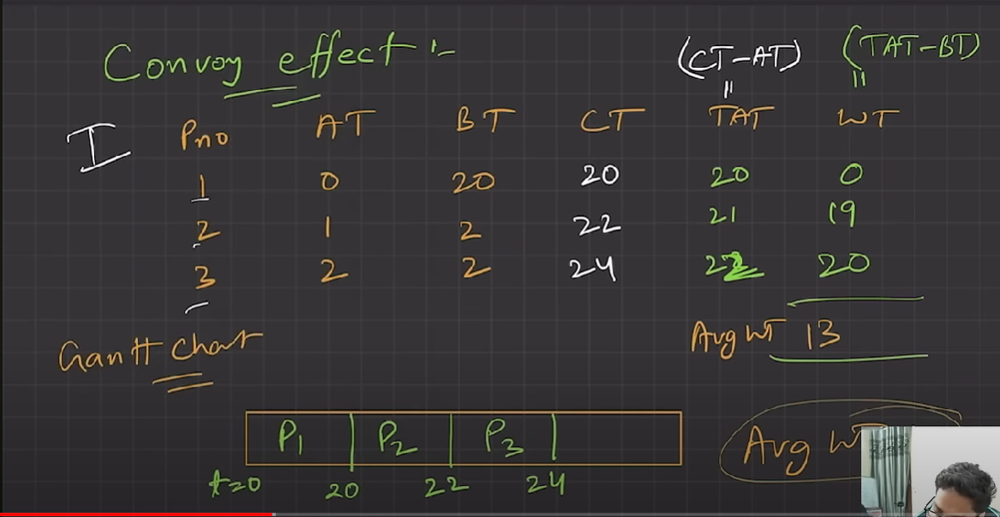

1. **Shortest job first:**

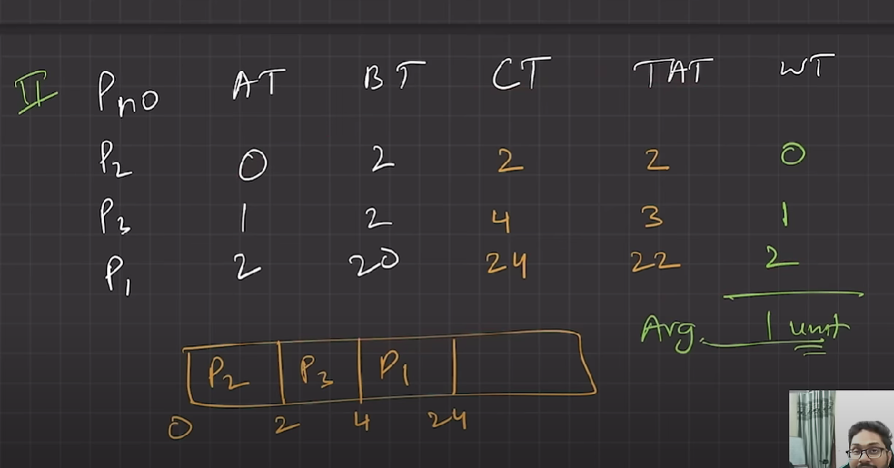

So, convoy effect states that if a job has higher BT then it will have the impact on the avg. waiting time of the of all the job.

1. **Non- Premptive Shortest job first (SJF):** the process with the least burst time is allocated CPU first,

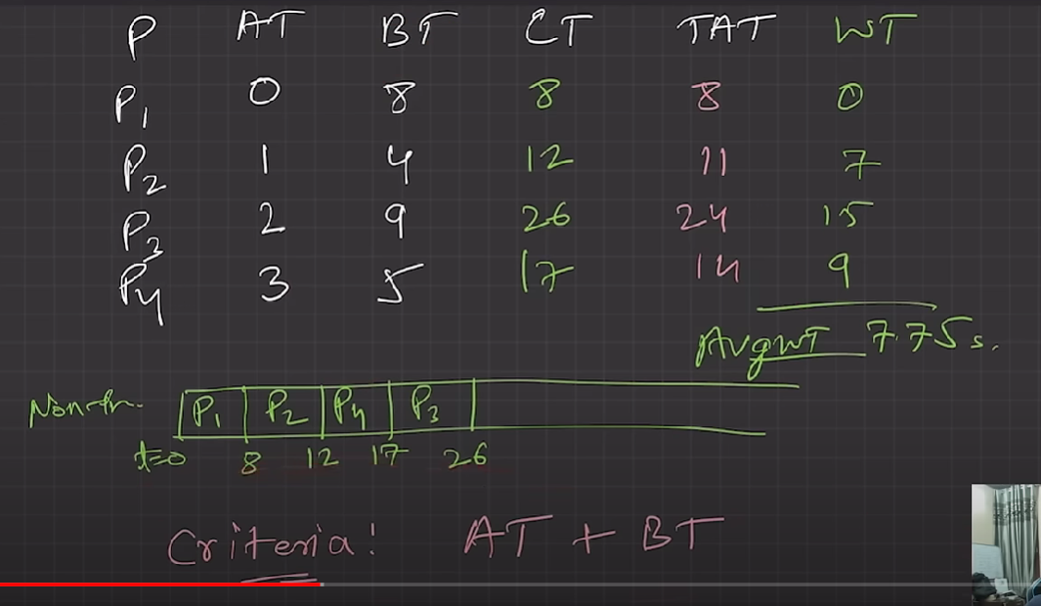

Pre-emptive version:

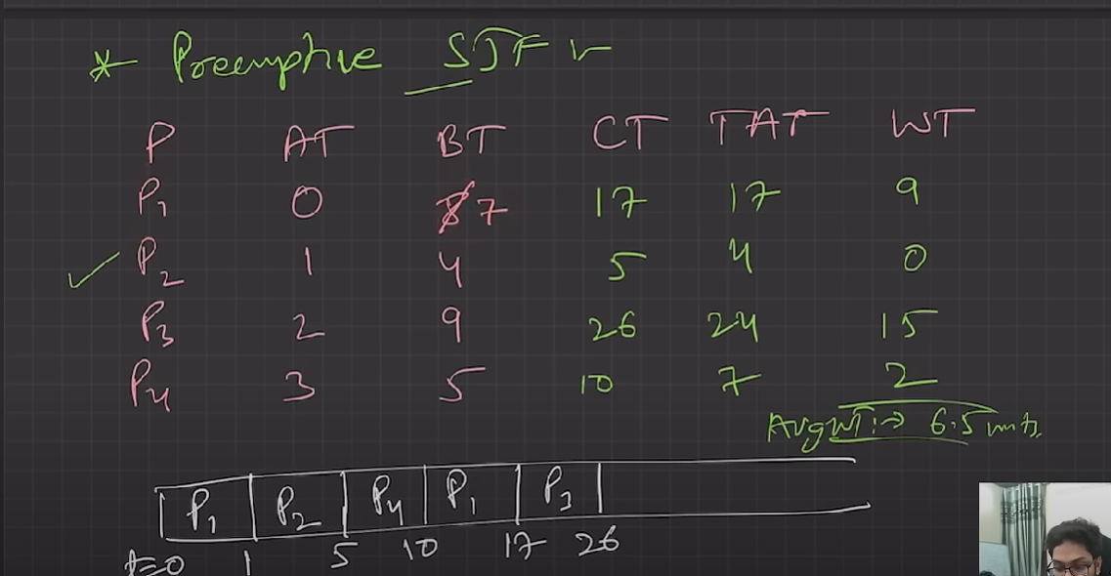

Now the question comes will there be convoy effect in this case, so the answer is NO as when any other job having burst time less than the executing job that will be stopped. So, less starvation in this case.

1. **Priority Scheduling:** we assign priority to each job,

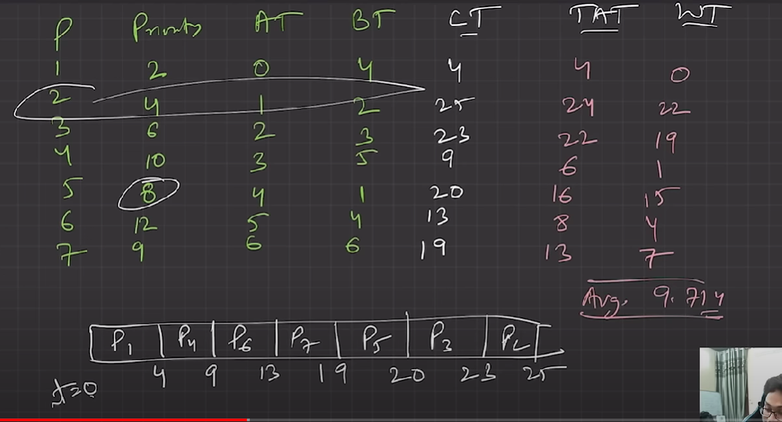

**Pre-emptive priority Scheduling**: A lot of overhead.

Biggest drawback of both pre-emptive and non- Premptive priority scheduling is indefinite waiting or extreme starvation.

Solution: gradually increase the priority of the job, as the age of the job increases.

1. **Round robin:** most popular and the pre-emptive version of FCFS. Its criteria is Arrival time and time quantum. Design time sharing, easy to implement, multi-tasking best suited. More the time quantum less the overhead and vice-versa.
2. 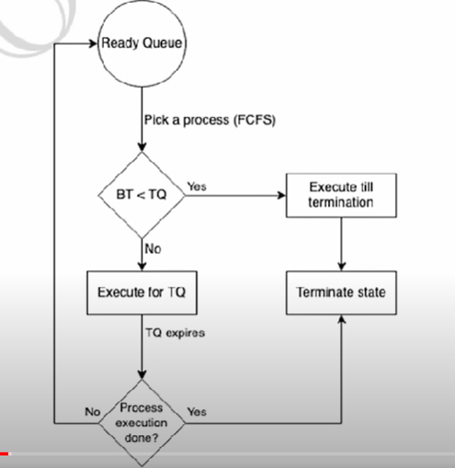

**Multi-level queue scheduling and comparison between the CPU scheduling algo?**

**System process:** created by OS. **FIRST PRIORITY**

**Interactive process:** requires user input. Also called foreground process. **SECOND PRIORITY.**

**Batch process:** these runs in the background, also called background processes**. LEAST** **PRIORITY.**

So, in multi-level queue scheduling convoy effect is present.

**Multi-level feedback queue scheduling:** multiple sub-queues, there is allowed to move in the inter-queue. Separate process based on BT, more the BT lower the priority, I/O bound and interactive process are kept in higher priority queue. Aging method is used to prevent starvation. Flexible and configurable OS design.

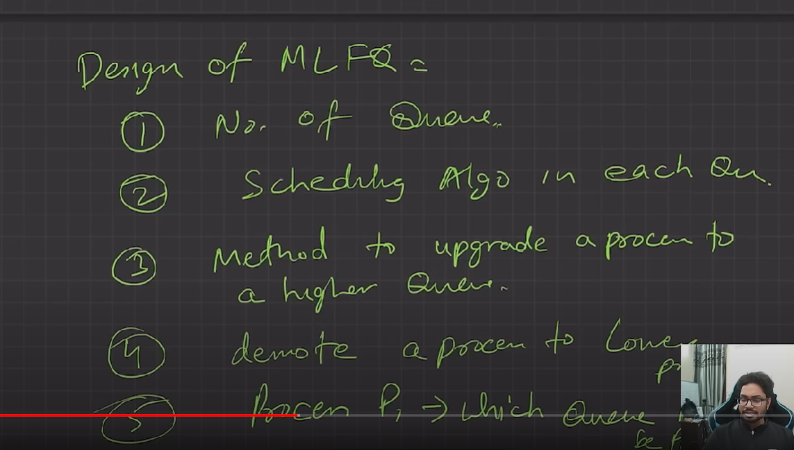

**Comparison of all the algo we have studied till now:**

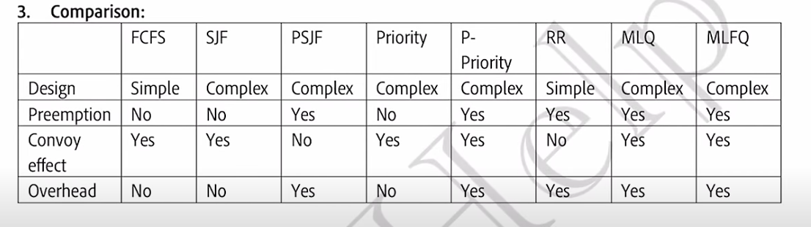

**What is concurrency?**

This executes multiple instructions at the same time. this is done using breaking the process the into threads and following the instruction.

For ex: in MS word (text editor, spell checker, text formatter) all three are different threads executes simultaneously. This is done using thread scheduling algo. Address space remains same, and context switching is very fast. But in single CPU there is no advantage we get.

**Benefits of multi-threading:**

1. **Responsiveness, more interactive.**
2. **Resource sharing is much more efficient.**
3. **Threads are economical.**
4. **Threads better utilize multi core CPU.**

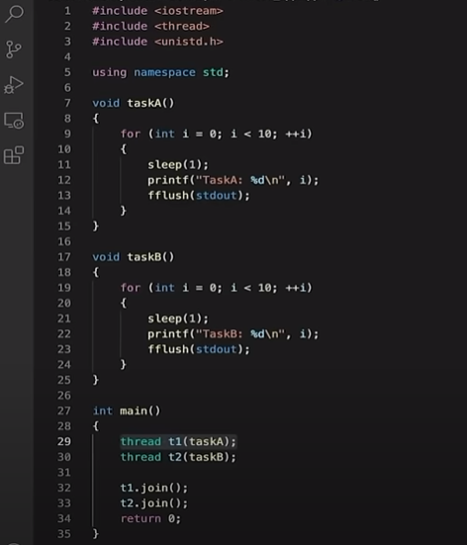

**Critical section problem:** The critical section problem in operating systems refers to the challenge of ensuring that multiple processes or threads can access shared resources or data in a way that prevents conflicts and ensures data integrity. The critical section is a part of the code where a process accesses shared resources. The problem arises because simultaneous access to shared resources can lead to data inconsistency or corruption.

**Ways to prevent Critical section:**

1. **Mutual exclusion:** Ensuring that only one process can be in the critical section at a time.
2. **Progress:** If no process is in the critical section, and there are some processes that wish to enter the critical section, then one of these processes must be allowed to enter the critical section.
3. **Bounded Waiting:** There should be a limit on the number of times that other processes are allowed to enter their critical sections after a process has made a request to enter its critical section and before that request is granted.
4. **Peterson's Algorithm**: A classical software-based solution for two processes that ensures mutual exclusion, progress, and bounded waiting.
5. **Lock Variables**: Simple variables used to control access to the critical section.

**Conditional variables and semaphore to synchronise thread:**

**Semaphore**: A more complex synchronization tool that can be used to solve the critical section problem for multiple processes. Semaphores use two atomic operations, **wait()** and **signal().**

**Producer and consumer problem and its solution:**

Also called as bounded buffer problem,

There are producer thread and consumer thread, there should be sync between producer and consumer, producer must not insert data when the buffer is full, also the consumer must not pick/remove data when the buffer is empty.

**Reader writer problem and its solution:**

In this there are two threads reader thread and writer threads. Note that there are one writer and multiple reader.

If there are multiple writers then race problem will occur and data will become inconsistence. Also, at the time when writer is writing the reader cannot read at that moment.

**Solution:**

**Mutex:** using binary semaphore, to ensure mutual exclusion, when read count is updated, no two threads modify read count the same time.

Write: this one also binary semaphore, common for both reader and writer.

**Read count:** integer initialized with 0.

**The dining philosopher’s problem:**

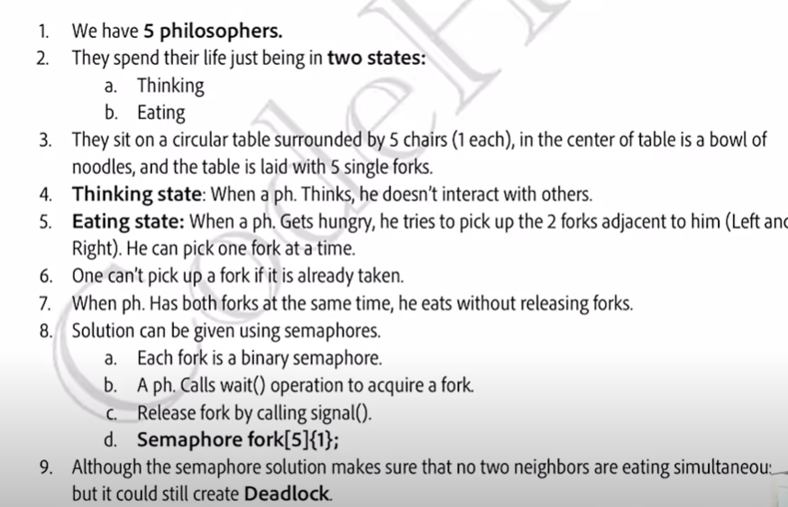

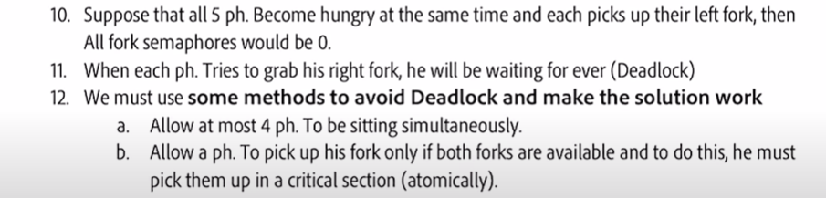

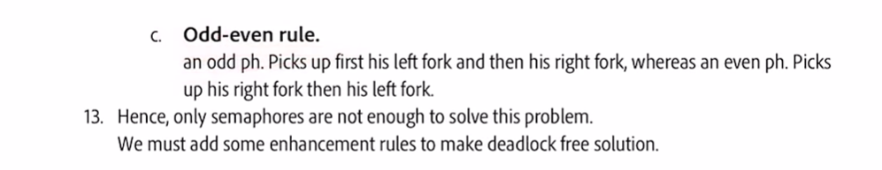

**What is a deadlock?**

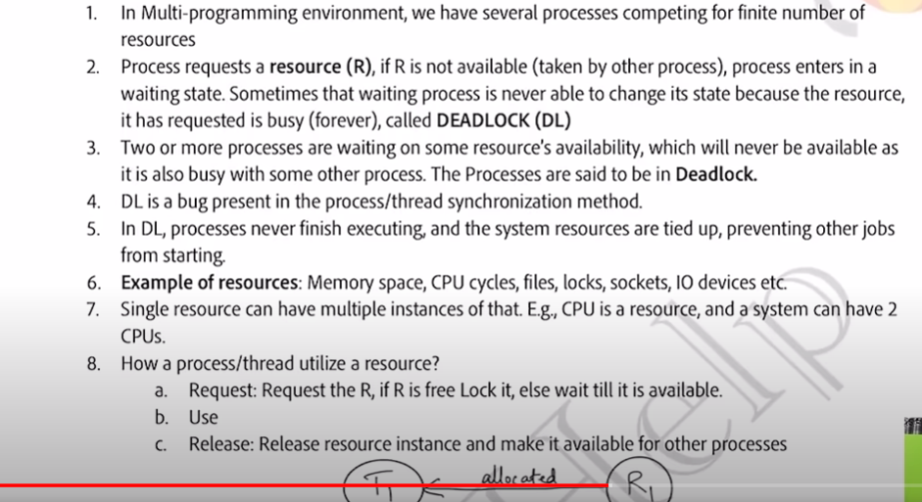

Necessary condition for deadlock:

1. Mutual exclusion.
2. Hold and wait.
3. No-premption.
4. Circular wait.

Method to avoid deadlock:

1. Deadlock prevention:

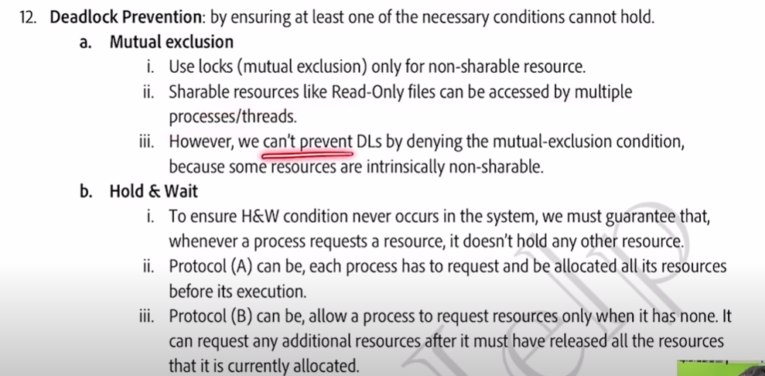

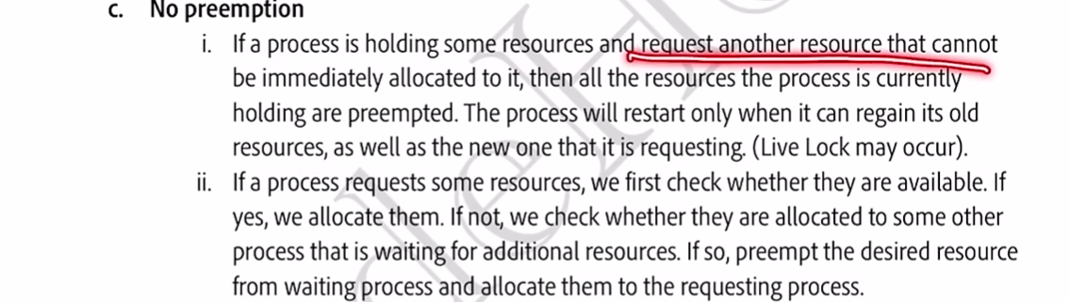

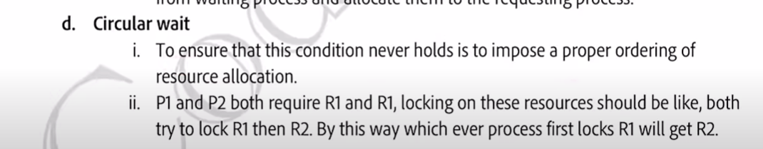

Solving leetcode problem on concurrency.

Print order – leetcode – 1114:

Fizz Buzz Multi-threaded – leetcode – 1195:

Dining’s philosophers’ problem – leetcode – 1226:

**Memory management in OS:**

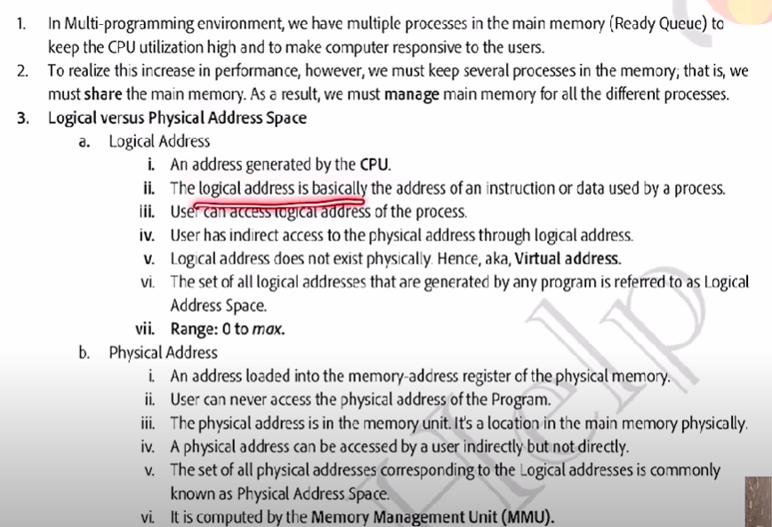

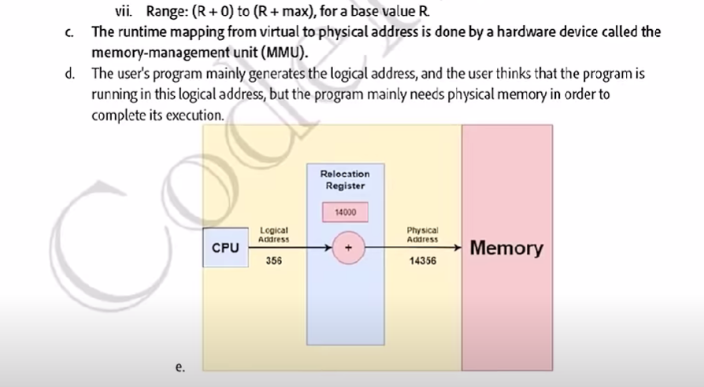

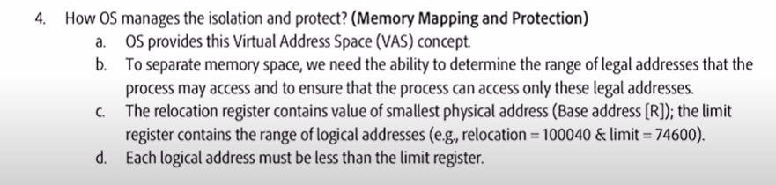

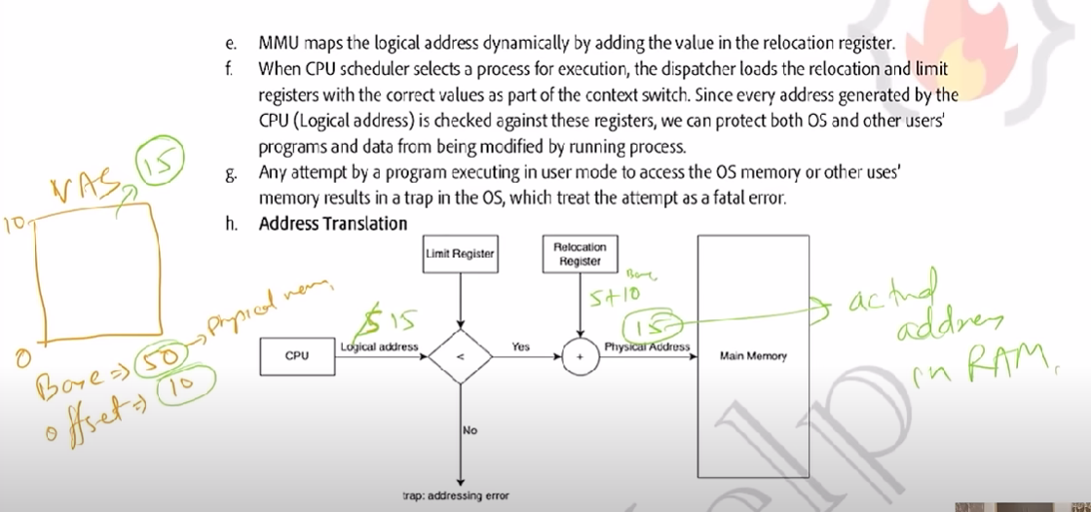

Memory allocation in physical memory:

1. Contiguous memory location: each process is contained in a single block of contiguous blocks.

For this we can do fixed partitioning (ram divided into partitions of equal size), in this we internal + external fragmentation. In this we have low degree of multi-programming.

1. Dynamic partitioning: in this technique, partition size is not declared initially, declared at the time process loading.

Advantages: no internal fragmentation. No limit on the size of the process. Better degree of multi-programming.

Disadvantage: external fragmentation.

**How operating system manages free space:**

This is done using defragmentation or compaction. There will be no effect on the user process as user works on logic memory and OS works on physical memory. There is only one issue in this and that is efficiency is decreased a bit as defragmentation is itself a time-consuming process. Linked list data structure is used to keep the track of the free space.

There are various algorithms which are implemented by the OS in order to find out the holes in the linked list and allocate them to the process:

1. First fit: we allocate the first hole that is big enough. For ex: the process is of 90kb and the linked list is:

50->100->90->200->50->null

So, we allocate the 90/100 as it is the first big space. Fast and easy to implement.

1. Next fit: now let suppose after the process p1 = 90kb is allocated the space and next process p2 = 10kb comes then it will be allocated not from the starting but just after the process p1 as 10kb of space is left in that 10/100.
2. Best fit: the process is allocated to the space that is just bigger than the process so it leaves the least amount of the space. In the above example we allocate 90kb of linked list space to p1. Least fragmentation internal, slow. Creates major external fragmentation.
3. Worst fit: we allocate the process the largest hole in case of 90kb of process we allocate 200 of the linked list holes. Lesser external fragmentation. slow

**What is paging?**

The logical address space is divided into pages and the physical address space(RAM) is divided into frames this is called paging and this is done using page table.

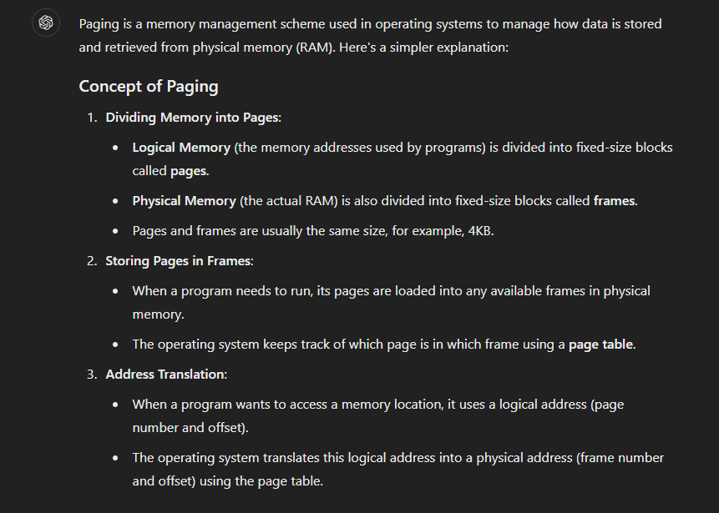

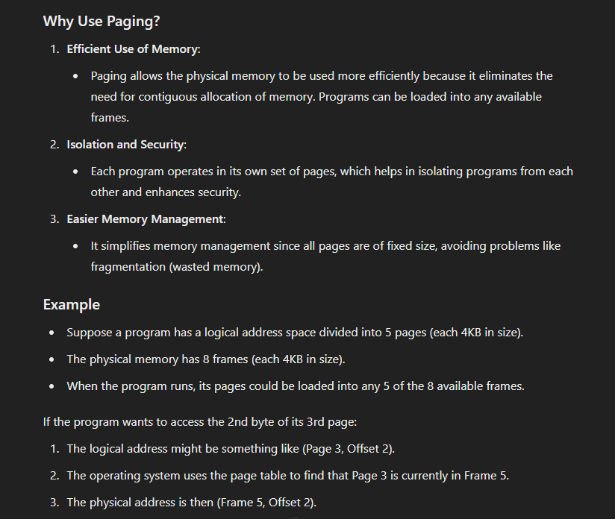

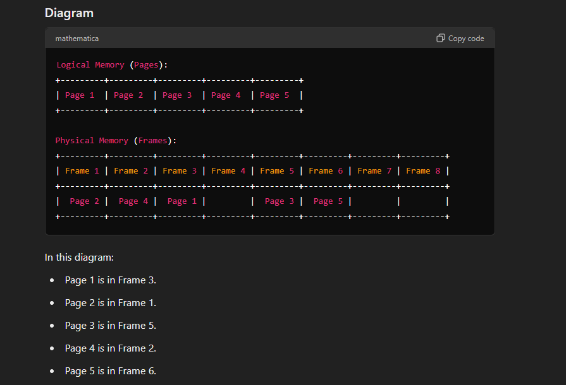

**What is segmentation?**

This handles not the fixed partitioning of the logical address space but variable partitioning of the logical address space. For ex: a function of code should not get divided into two parts but they should remain intact.

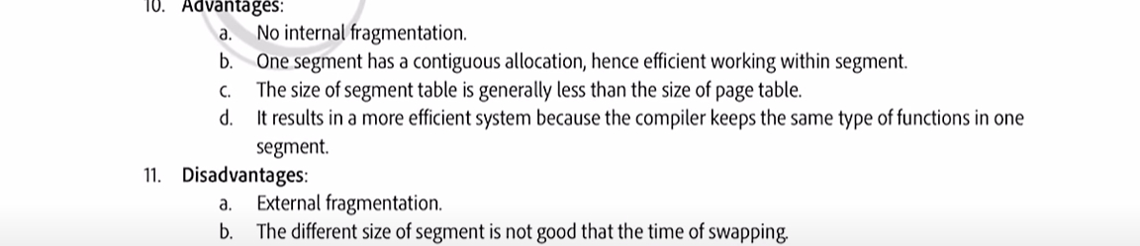

**What is virtual memory?**

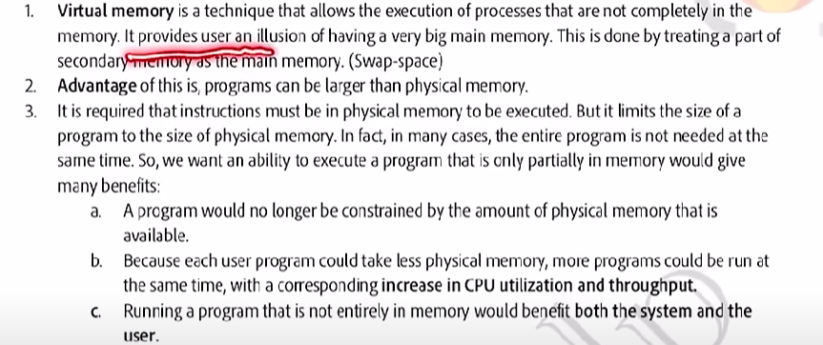

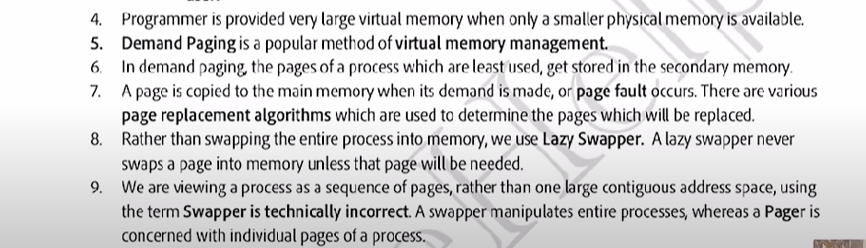

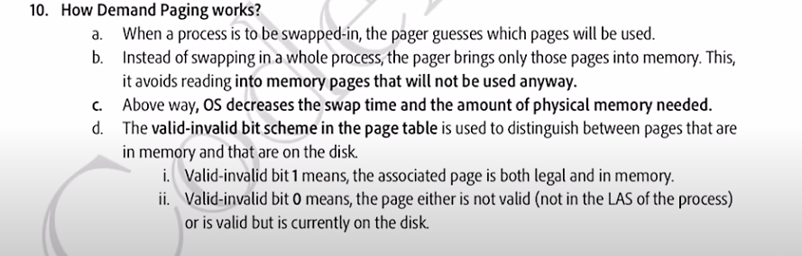

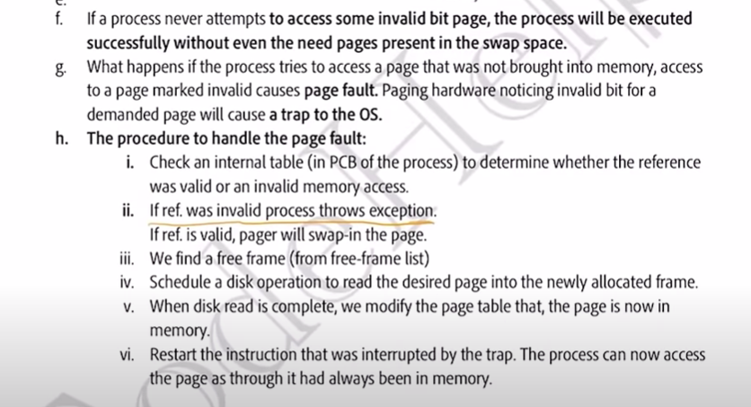

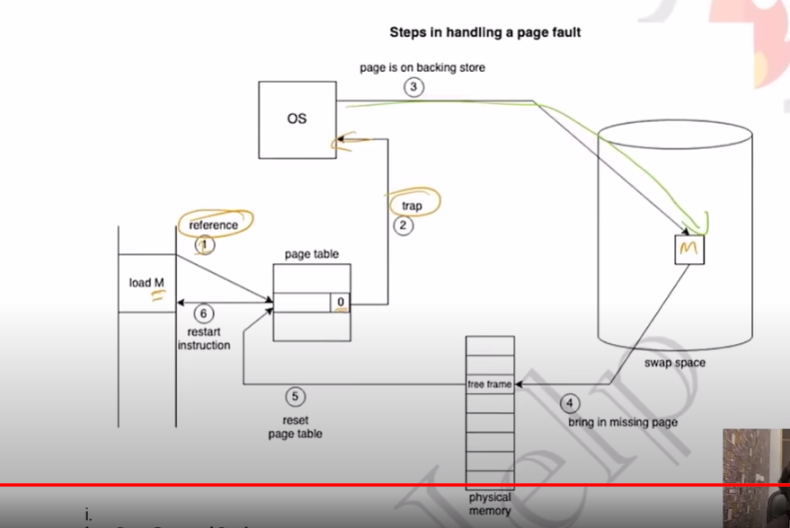

**Study more about demand paging and pure demand paging.**

**Page replacement algorithm:**

Page fault, in this RAM is divided into multiple pages or frames and these frames are allocated to different processes, now what happens not all the pages of the process are loaded but only the required ones are allocated the frame and whenever we requires other pages we just swap it with what we don’t want at the moment, the page that we want to swap is present in swap area. This complete process is called page fault and the time taken is called page fault service time.

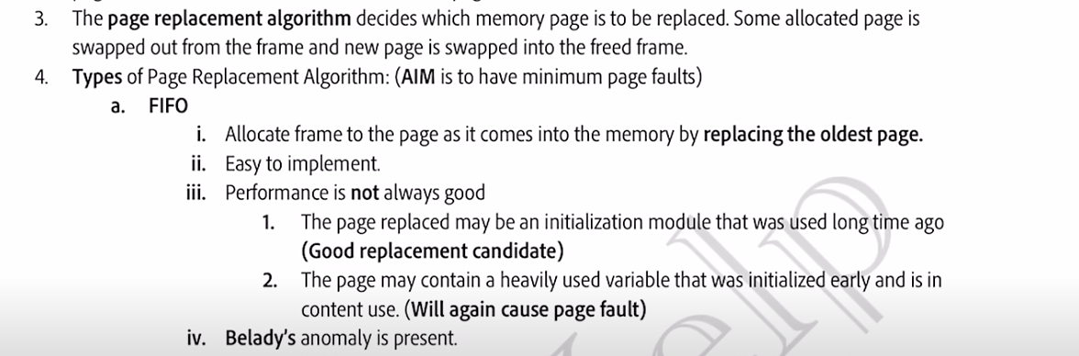

Second method is, **Optimal page replacement:**

1. Best algorithm.’
2. Page fault minimum.
3. Almost impossible to implement.

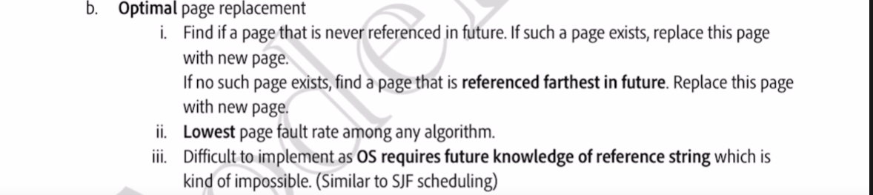

Now, the third algorithm is, **LRU Cache:**

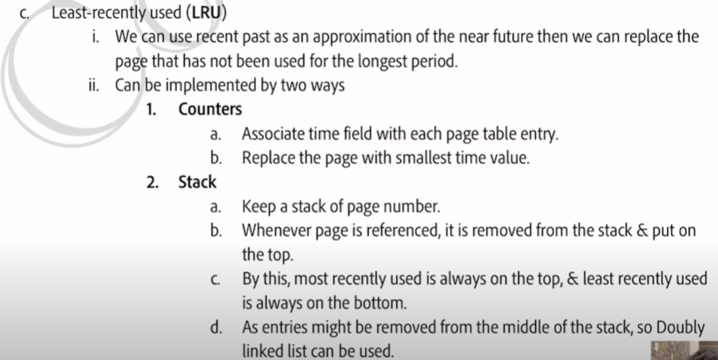

**What is thrashing?**

